**Lab Objectives**

* Scenario Manager, What if and Goal seeking
* Regression and forecasting

**Exercise # 1:** Given the data in the sheet “Family Budget”,

We will conduct a What-If Scenario to see how the remaining income will change by changing any of the outgoings values. The scenario will be changed according to the below table:

|  |  |  |
| --- | --- | --- |
| **Outgoing** | **Current Value** | **Scenario #1** |
| Food | 400 | 390 |
| Clothes | 560 | 530 |
| Phone Bills | 100 | 50 |

**Solution Steps:**

* From the Data tab choose What-If Analysis
* Then add a new scenario and name it “New Budget”, then choose the cells to be changed. Then Press OK.
* In the new window enter values for each of the changing cells as mentioned in the previous table then press OK.
* After that press Summary, in the result cell add reference to the Total Outgoings cell, Income Cell and the Income left cell by typing “,” between each.
* 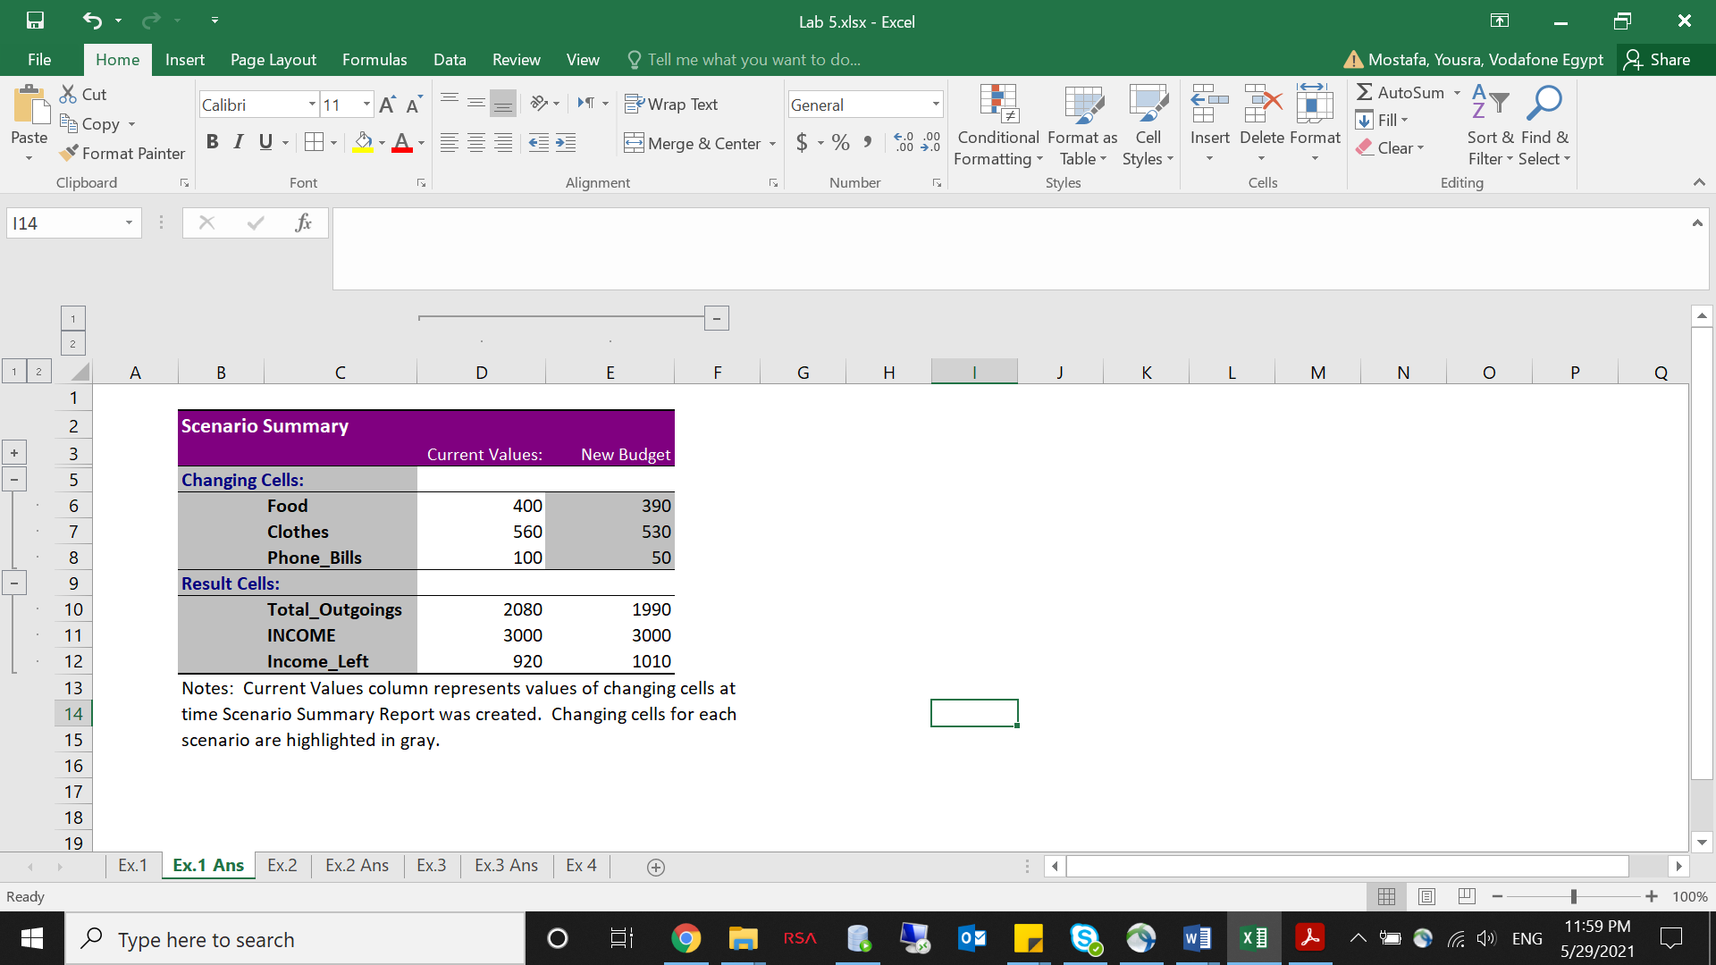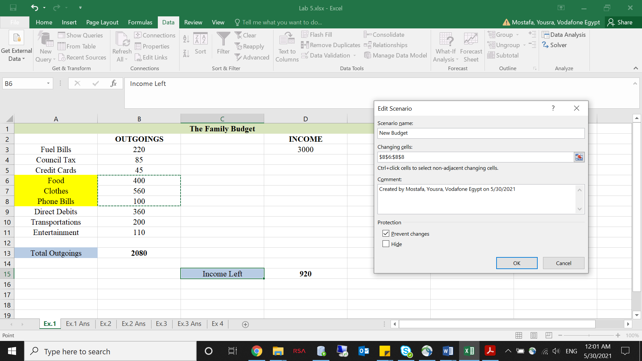The result will be in another sheet.

**Exercise # 2:** In a new sheet, solve the following problem:

We are selling 1,000 unit of an item, with the price of each item at $25. What should be the price of each item that would lead to a goal profit of $30,000?

**Solution Steps:**

* Go to the Data tab -> What-if Analysis -> Goal Seek
* Set cell: *profit*, to value: *$30,000*, by changing: *price*

Alternatively, what would be the number of items that must be sold, given that the price is $25 each, in order to reach a goal profit of $30,000?

**Solution Steps:**

* Go to the Data tab -> What-if Analysis -> Goal Seek
* Set cell: *profit*, to value: *$30,000*, by changing: *items*

**Exercise # 3:** In a new sheet, solve the following problem:

We have a Loan with value 20,000. The interest rate for this loan is 12% and you have to pay it back over a 50 months period. Calculate the monthly payment.

* How will the monthly payment be affected if the interest rate is changed? The interval of change is [10% ->15%] with 1% increment.

**Solution Steps:**

* + We make a column to represent all values that we need to investigate (i.e different interest rates)
  + The header of the column next to it contains a reference to the function we want to know the effect of change on (i.e. monthly payment)
  + Select the 2 columns, and then from what-if Analysis -> Data Tables -> put in the column cell the reference of cell B3 that contains the original rate.
* Use the Data Table to see how the payment will be affected if both the interest rate and the payment period are changed. The interval of change for the interest rate is [10% -> 15%] with 1% increment. The interval of change for periods is [30 -> 60] with 10 periods of increment.

**Solution Steps:**

* We make a column to represent all values that we need to investigate as a first attribute of change (i.e different interest rates)
* We make a row to represent all values that we need to investigate as a second attribute of change (i.e number of periods)
* The cell between rows and columns (the one in the upper left corner) should contain a cell reference to the function we want to know the effect of change on (i.e. monthly payment)
* Then we refer to the whole table (including the rows and colimns of the values to be tested) -> data -> what if analysis -> Data table
* Put in the column cell the reference of cell B3 that contains the original rate.
* Put in the row cell the reference of cell B4 that contains the original number of periods.

**Exercise # 4:** Given the data in the sheet “Sales”,

We have the daily sales for a product from the 1st of January 2019 to the 31st of March 2019 and we need to predict those of April 2019.

We will make it using 4 different approaches:

1. Forecast Function
2. Trend Function
3. Slope and Intercept Functions
4. Using the regression function (make the scatter plot then draw the trend line and get the regression function).